

**DATA STRUCTURES LAB**

**WEEK-6**

**NAME : ABHISHEK KUMAR JHA**

**ROLL NO : 19R21A05C2**

**DATE : 5/1/2021**

**PROBLEM STATEMENT:**

Write a C program to implement Insertion Sort and Selection Sort

**CODE:**

**INSERTION SORT**

#include<stdio.h>

void sort(int a[],int n)

{

int i,j,temp;

for(i=1;i<n;i++)

{

temp=a[i];

j=i-1;

while(temp<a[j]&&(j>=0))

{

a[j+1]=a[j];

j=j-1;

}

a[j+1]=temp;

}

}

int main()

{

int i,n,a[50];

printf("Enter no of elements\n");

scanf("%d",&n);

printf("Enter elements\n");

for(i=0;i<n;i++)

scanf("%d",&a[i]);

printf("Elements before sorting\n");

for(i=0;i<n;i++)

printf("%d\t",a[i]);

sort(a,n);

printf("\nElements after insertion sort\n");

for(i=0;i<n;i++)

printf("%d\t",a[i]);

}

**Output:**

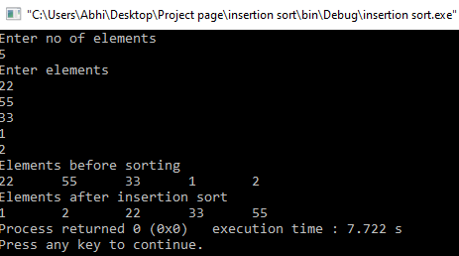

**CODE:**

**SELECTION SORT:**

#include<stdio.h>

void ssort(int a[],int n)

{

int i,j,min,temp;

for(i=0;i<n-1;i++)

{

min=i;

for(j=i+1;j<n;j++)

{

if(a[min]>a[j])

min=j;

}

temp=a[i];

a[i]=a[min];

a[min]=temp;

}

}

int main()

{

int i,n,a[50];

printf("Enter no of elements\n");

scanf("%d",&n);

printf("Enter elements\n");

for(i=0;i<n;i++)

scanf("%d",&a[i]);

printf("Elements before sorting\n");

for(i=0;i<n;i++)

printf("%d\t",a[i]);

ssort(a,n);

printf("\nElements after selection sort\n");

for(i=0;i<n;i++)

printf("%d\t",a[i]);

}

**Output:**

